Module02 Assignment: A Simple Web Application

In this “hands-on” activity, you will learn about creating web pages that use ASP.NET, HTML5, and CSS3. This activity will take you about 3 to 6 hours, so plan accordingly!

The activity consists of the following steps:
- Study web resources.
- Read the book
- Create a demo.
- Write a paper.
- Submit work to Canvas.

Study web resource:
Please familiarize yourself with the following topics.

- CSS3 (from CSS3 Introduction to CSS3 Rounded Corners)
http://www.w3schools.com/css/css3_intro.asp
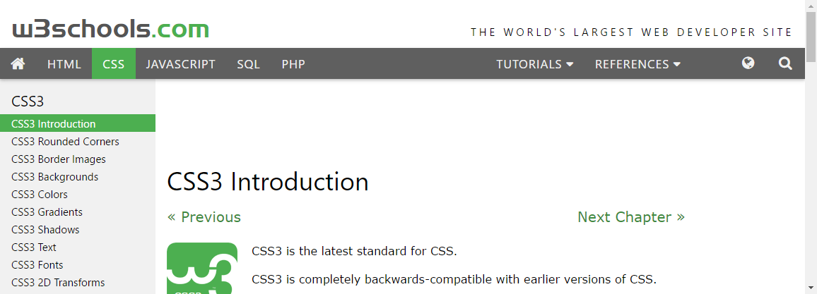

- HTML5 (from HTML5 Intro to HTML5 Semantic)
http://www.w3schools.com/html/html5_semantic_elements.asp

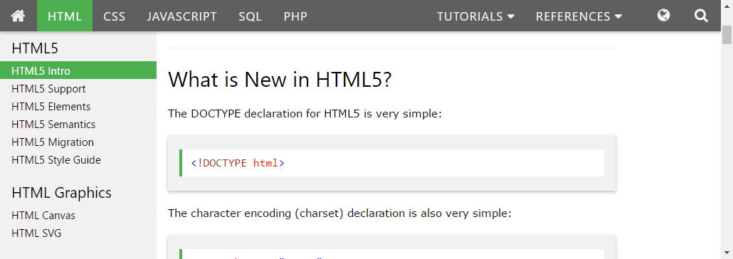

Read Your Book:
The second part of the book details the basics you need to know about web development using C#. This week we will only deal with the 4th chapter.

Create your own demo
Now that you have seen how others describe and demonstrate these concepts let’s try out your skills by creating a new ASP.NET page and Word document that illustrates how to create an ASP.NET, HTML5, and CSS3 registration page.

This page will write data to a text file using C# code, but you will collect the data from the user with HTML5 code, and make it look professional with CSS code.

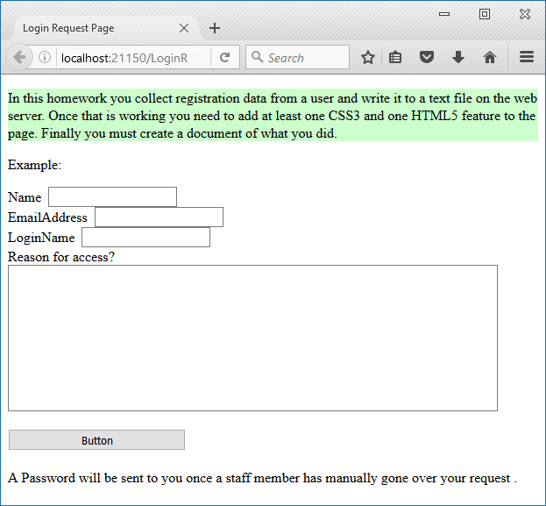

Tip: Although we covered this is the class session, it is always nice to see another example, so look at this one. https://asp-net-example.blogspot.com/2009/01/how-to-create-text-file-and-write-text.html. Ask yourself what could be done to make this demonstration/tutorial better and keep that in mind for the next task.

Write a document
Create a Word document that outlines how your assignment's ASP.NET page works. Include screenshots, please. The document should be about two pages in length. Please use Microsoft Word or something compatible with your paper.

Note: Make sure you put it in a proper, professional level, formatting! It does not have to be perfect, but if you turn in a simple blob of text, you will not get credit for it! Here is a link that may help you understand what I am looking for https://youtu.be/9ojhSW9ljjo
(External Site)

Submit your work to the Canvas site.
After you complete you your demo and paper, place the resulting files and folders into another folder, both the document and the Visual Studio Solution/Project sub-folder, and turn everything into a single zip file. Then post the zip file on the Canvas website, in the appropriate module under Assignments.
(http://www.wikihow.com/Zip-Files-Together)

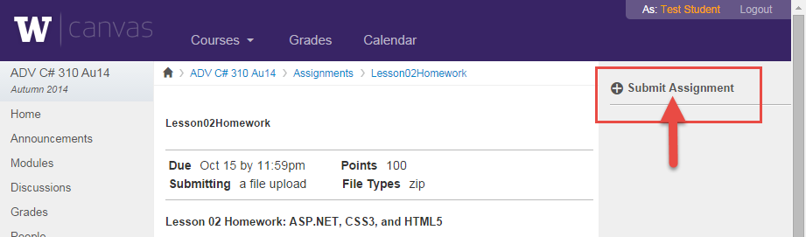

You’re done!

